EPSON UNDER 18 TOURNAMENT
WAIKANAE, WELLINGTON, NZ

SUNDAY 16 APRIL 2006

Venue Location: Waikanae Memorial Hall, Pehi Kura Street, Waikanae

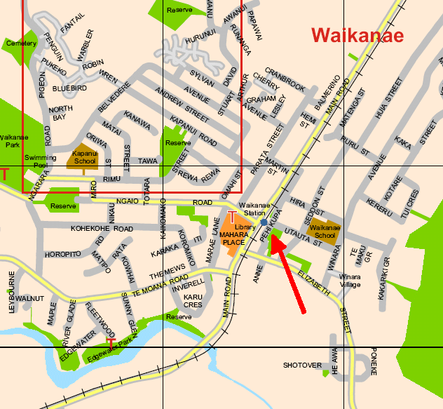

To Reach the Venue From Wellington:

Drive North from Wellington on State Highway 1 until you reach Waikanae (approximately 60km North of Wellington). Turn Right at the second set of Traffic Lights over the railway lines, then take your first left into Pehi Kura Street

To Reach the Venue From North of Waikanae:

Drive South into Waikanae on State Highway 1. Turn Left at the first set of Traffic Lights over the railway lines, then take your first left into Pehi Kura Street

